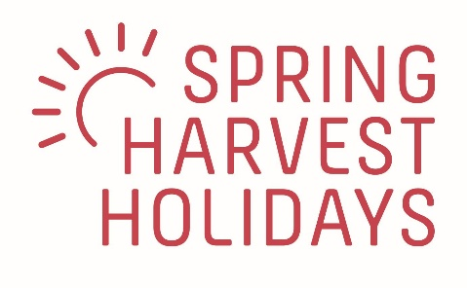

Role description

Job Title: Programme Manager 2025

Reporting to: LPO Park Director

Out of season role, up to April 2025. Ad hoc hours, estimated five days

- Support final recruitment and prepare the seasonal animateur team
- Plan training
- Prepare on-site curriculum and activities plan

In-season role, May – September 2025. Full time. Reporting to the Park Director

- Delivery of programme and activities on site
- Care and development of animateurs
- Liaison and communication with on-site managers and teams

- Programme delivery: Support and empower team leaders to take responsibility for each age group and activity, meeting regularly for feedback and encouragement. Ensure quality control to maintain excellent standards across all age groups. In partnership with the Park Director, welcome, induct, support and direct the speaker, worship leader and pastoral team.
- Animateur team: Support our HR Manager ensuring our animateur team is cared for physically, emotionally and spiritually. Support the implementation of the rota of working hours. Ensure that that the team is given good direction, leadership, with an emphasis on developing the animateurs skills and confidence.
- Activities and entertainments: Plan and deliver a high-quality programme of activities and entertainments, creating community and drawing guests together for activities with varied and wide appeal. Coordinate activities with the commercial team to ensure guest satisfaction, adequate staffing and maximum sales.
- Safeguarding: In partnership with the Director and HR Manager, encourage a culture where children and vulnerable adults are safe and feel they are in a safe environment. Ensure the animateur team is trained in safeguarding and follows procedures when required.
- Communication: Liaise regularly with the Park Director to ensure that information is shared, key goals achieved, issues resolved and resources deployed to ensure excellent guest experience and optimum commercial performance.

Requirements for the post holder:
This role holds an occupational requirement under the Equality Act for the post-holder to be a practising and committed Christian, seeking to grow in their discipleship, and an active and regular worshipping member of a Christian church. You will also be able to demonstrate your commitment to the core values of Spring Harvest Holidays.
Successful candidates must be willing to serve within the EA Basis of Faith and Lausanne Covenant
The successful applicant will be employed by Essential Christian on a UK contract and seconded to work for Spring Harvest Holidays in France. It will therefore be necessary to obtain a volunteer visa prior to working in France. Applicants from European countries are encouraged. Eligibility to work in the UK is not required for this role. We are able to offer a European contract and reserve the right to change the terms and conditions of employment to meet the legal requirements of a French employment contract prior to confirming employment.

Person Specification
Character: | - Confident relaxed public speaker, able to host Christian meetings, entertainments and sports activities.  - Creative, able to create new and exciting spiritual programmes for children and young people and entertainment and sports activities for guests of all ages  - Customer service focussed, able to ensure high guest enjoyment and engagement of programmes and activities organised.  - Organised, able to oversee overlapping programmes and activities delivered by multiple teams across a full and busy 7 day a week programme.  - Team focussed, able to develop a large team to deliver programmes and activities, developing skills and confidence while ensuring high quality delivery.  - Flexible, able to support the wider team in delivering the vision of Spring Harvest Holidays.
Competency: | - Ability to appropriately handle sensitive and confidential information  - Fluent in English
Experience: | - Planning and delivering spiritual programmes for children and young people in a church and/or educational environment.  - Planning and delivering entertainment and/or sports activities for all ages  - Managing a team to deliver spiritual, entertainment and sports activities  - Understanding of risk assessment process to ensure all programmes and activities are safe and compliant with legislation  - Understanding of good safeguarding practices to ensure the safety and well being of children and vulnerable adults.
Desirable: | - Experience of Spring Harvest Holidays as a guest  - Experience of working in the Holiday Entertainment sector  - French, Dutch or German speaker

Terms & Conditions of Employment
Location: | Based at Le Pas Opton in the Vendée region of Western France
Contract: | Seasonal. Fixed term contract  Full-time  May 2025 to September 2025
Working Hours: | 39 hours per week to be worked over a 6-day period
Salary: | £29,700 per annum, pro rata
Accommodation: | Accommodation provided in a mobile home – classed as a benefit in kind
Holidays: | 28 days per annum, pro rata
Probationary Period: | 1 month
Notice Period: | 1 week, increasing to 1 month on satisfactory completion of probationary period
References & DBS: | Employment will be subject to satisfactory references being obtained and an Enhanced DBS certificate.


Essential Christian, 14 Horsted Square, Uckfield, East Sussex, TN22 1QG
Essential Christian, Registered charity no. 11268997. A company limited by guarantee: Registered in England and Wales, number 6667924 @essentialchristian.org.

